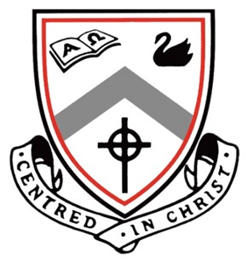
Ursula Frayne Catholic College

Audition Application Form for 2023
HONK !

By completing and returning this form to the Front Office Student Services (Balmoral Street Campus) or email Ms Davies-Moore ( judy.davies-moore@ufcc.wa.edu.au) by Monday, November 21st, 2022, you will be accepted to audition. Auditions will occur on Friday 25 November 11, 2022 at the Balmoral Campus. You will be sent a time and a place for the audition via your parents’email address.
Any queries, please contact Ms Davies‐Moore (Director), or Ms Bussanich (Vocal Director) on the Duncan
Street Campus.

AUDITION ELIGIBILITY

Any student currently enrolled in Year 3 , 4, 5 or 6 who are attending UFCC in 2023.

NAME: FORM/CLASS:

HOME PHONE NO: AGE (2023):

PARENT EMAIL ADDRESS

Tick as many boxes as you wish

I wish to audition for:

PRINCIPAL ROLE CHORUS

STUDENT’S SIGNATURE: DATE:

PARENT’S SIGNATURE: DATE:

AUDITION REQUIREMENTS

All College students wishing to be involved in the 2023 production of Honk ! , will need to commit to the February‐May 2023 Production Rehearsal Schedule. Successful students will receive it with their contract and script. The Rehearsal Schedule will involve a camp (for principal characters and orchestra), after school rehearsals and selected weekend rehearsals in April/May. All rehearsals will be held at the Duncan Street Campus of Ursula Frayne Catholic College. Successful students may also be required to perform at the Catholic Schools’ Performing Arts Festival. Students who are unable to guarantee attendance at the majority of rehearsals and special performances throughout 2023 should not apply.

PRINCIPAL ROLES Please read the descriptions available on the school website look under Arts and it will take you to the heading Honk ! . Pick a piece of audition script. You do not have to be word perfect but familiar.

Students wishing to audition for a role in Honk! will need to prepare: This is on the website too

- A song from Honk ! entitled “A Poultry Tale” ( It has been downloaded in this package)

b) Prepared script extract(s) the character descriptions are provided (also on the website).

CHORUS -
You will need to prepare a song from the musical – entitled ‘A poultry Tale’.

