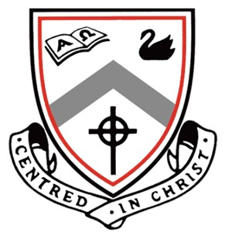
Ursula Frayne Catholic College

Audition Application Form for Year 10, 11 and 12
HONK !

By completing and returning this form to the Front Office Student Services (Duncan Street Campus) or Direct Message Ms Davies-Moore by Monday, November 14th, 2022, you will be accepted to audition. Please sign up on the shared drive for an audition time.
Any queries, please contact Ms Davies‐Moore (Director), or Ms Bussanich (Vocal Director) on the Duncan
Street Campus.

AUDITION ELIGIBILITY

Any student currently enrolled in Year 9 to Year 11 (2022) who is attending UFCC in 2023.

NAME: FORM/CLASS:

HOME PHONE NO: AGE (2023):

STUDENT EMAIL ADDRESS:
PARENT EMAIL ADDRESS FOR New STUDENTS

Tick as many boxes as you wish

I wish to audition for:

PRINCIPAL ROLE CHORUS

STUDENT’S SIGNATURE: DATE:

PARENT’S SIGNATURE: DATE:

AUDITION REQUIREMENTS

All College students wishing to be involved in the 2023 production of Honk ! (including back stage), will need to commit to the February‐May 2023Production Rehearsal Schedule. Successful students will receive it with their contract and script. The Rehearsal Schedule will involve a camp (for principal characters and orchestra), after school rehearsals and selected weekend rehearsals in April/May. All rehearsals will be held at the Duncan Street Campus of Ursula Frayne Catholic College. Successful students may also be required to perform at the Catholic Schools’ Performing Arts Festival. Students who are unable to guarantee attendance to the majority of rehearsals and special performances throughout 2023 should not apply.

PRINCIPAL ROLES

Students wishing to audition for a role in Honk! will need to prepare:

- A song from Honk ! entitled “A Poultry Tale” ( It has been downloaded in this package)

b) Prepared script extract(s) the character descriptions are provided (also on the website).

CHORUS

You will need to prepare a song from the musical – entitled ‘A poultry Tale’.

ORCHESTRA

All orchestra positions have been filled and will be conducted Frayne’s Band Director, Mr Ashley Baker.

NON STAGE ROLES (Backstage/Front of House)

Middle and Senior School students are encouraged to assist where needed. Names compiled from the Audition Application Form will be forwarded to the staff member coordinating each specific area, who in turn will approach students early in 2023.

