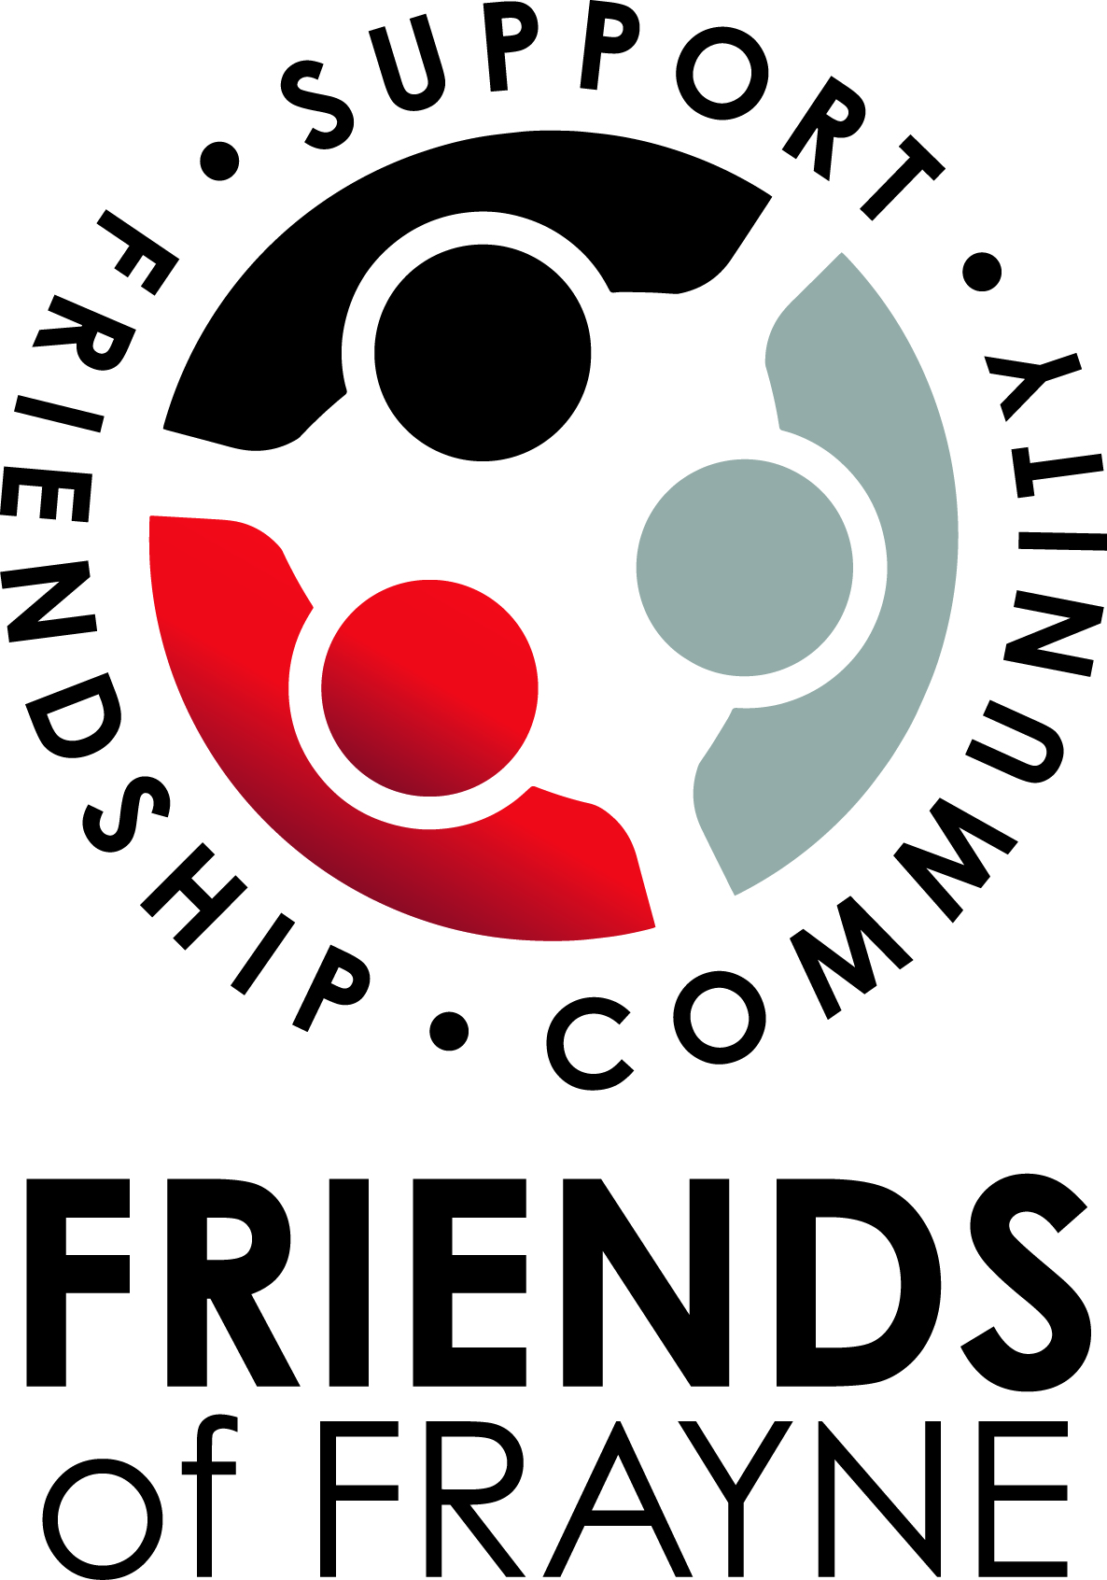
FRIENDS OF FRAYNE

MEETING AGENDA
URSULA FRAYNE: BALMORAL CAMPUS – WEDNESDAY 16th NOVEMBER 2022 7:00PM
Facilitator: Nikki Middleton (President)
Note Taker: Heather Fraser (Secretary)

PREPARATION FOR MEETING
Requires attendees to read minutes from previous meeting 26th October 2022 and action any outstanding items.

ACTION ITEMS FROM PREVIOUS MEETING

ITEM | RESPONSIBLE | DUE DATE
Welcome and Prayer
Apologies
Approval of Previous Minutes
Reports  - Principal’s report  - President’s report  - Duncan Street Campus report  - Balmoral Street Campus report  - Treasurer’s report  - College Advisory Council Nominee’s report | - Geoff  - Nikki  - Pat  - Jess  - Sue  - Julie-Anne
Matters arising from previous minutes.  - Terms of Reference – 1. Introduce the new model of operation for P&F groups in CEWA schools and the reasons for adopting the P&F Group Terms of Reference. Discussion. 2. Motions to be voted on to action the transition to the new model of operation.  - Review/update of Executive Council and Friends of Frayne Council role descriptions.  - Small Grants Applications | - Nikki  - Nikki
Matters for Discussion.
- Events for 2023 – Parent event and Movie night pre-planning

Next Meeting – College AGM: Tuesday 22nd November 2022 (Duncan Campus)
Closure of meeting

