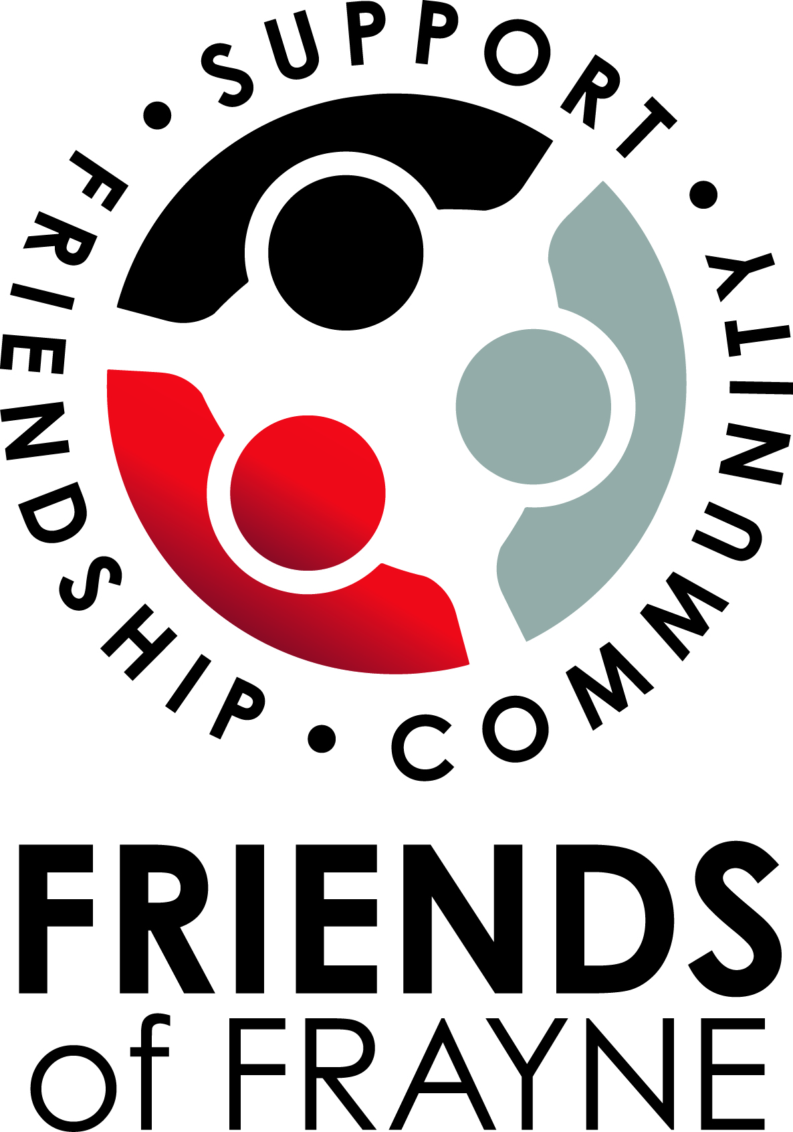
FRIENDS OF FRAYNE

MEETING AGENDA
URSULA FRAYNE: BALMORAL STREET CAMPUS – MONDAY 8TH NOVEMBER 2021 7:00PM
Facilitator: Sally Okoye (Duncan Campus Coordinator) and Jess Pochintesta (Balmoral Campus Coordinator)
Note Taker: Heather Fraser

PREPARATION FOR MEETING
Requires attendees to read minutes from previous meeting 19th October 2021 and action any outstanding items.

ACTION ITEMS FROM PREVIOUS MEETING

ITEM | RESPONSIBLE | DUE DATE
Welcome and Prayer
Apologies
Approval of Previous Minutes
Reports  - Principal’s report  - Duncan Street Campus report  - Balmoral Street Campus report  - Treasurer’s report  - College Advisory Council Nominee’s report | - Geoff  - Sally  - Jess  - Jasmine  - Julie-Anne
Matters arising from previous minutes.  - Catholic School Parents WA Inc  - Forward planning for 2022  - Financial update | - Sally/Jess  - Sally/Jess  - Sally
Matters for Discussion.  - Kindy 2022 Parent information evening (Wednesday 10th November)  - Parent Event (Saturday 13th November)  - Year 6 graduation and farewell | - Jess  - Jess/Sally  - Nikki
Next Meeting -AGM Tuesday 23rd November 2021 (Duncan Campus)
Closure of meeting

